**AD130: Web Application Development - Capstone Project Part 2**

**Capstone Project Overview**

**The Bookr Project**

Throughout this book, you'll be progressively building an app called **Bookr**. It is designed to let users browse and add book reviews (and books as well). As you complete the exercises and activities in each chapter, you'll be adding more features to the application. The GitHub repository for this book contains individual folders for the exercises and activities. These folders will usually include the files where the code of the app has changed.

**The Final Directory**

Each chapter's code will also have a directory called **final**. This directory will include all the code written for the app through to the end of that chapter. So, for example, the **final** folder for *Chapter 5*, *Serving Static Files*, will contain the full code for the Bookr app until the end of that chapter. That way, if you lose progress, you can use the code in the **final** folder of, say, **Chapter 5**, to start **Chapter 6**.

The following screenshot shows how the directory structure would appear for a chapter after downloading the code from the GitHub repo to disk (refer to the *Installing the Code Bundle* section for more details on how to download the code from the repo):

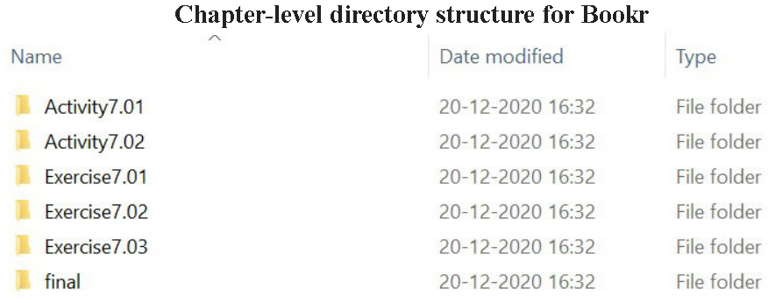

**Capstone Project Part 2 Description:**

Complete Activity sections in **Chapters 4, 5 and 6**:

* **Activity 4.01: Customizing the SiteAdmin**
* **Activity 4.02: Customizing the Model Admins**
* **Activity 5.01: Adding a reviews Logo**
* **Activity 5.02: CSS Enhancements**
* **Activity 5.03: Adding a Global Logo**
* **Activity 6.01: Book Searching**

Submit your files to **Capstone** **Project Part 2 in Moodle**.

**FOR INSTRUCTOR USE ONLY**

**Grading Rubric**

*Grading accepts a start value of 100. Points will be deducted for failure to fully complete or meet the stated requirements. Grading: 90-100 = Represents work of superior quality (A); 80-89 = Represents work of good to very good quality (B); 70-79 = Represents adequate command of class content (C); 69 and below = Represents work that shows a need for development or improvement (F); 0 = Represents plagiarized work (F).*

**AD130: Web Application Development (NCP-WEB)**

**Student:**

**Instructor:**

**Date:**

**Capstone Project Part 2**

|  |  |  |
| --- | --- | --- |
| **Description of requirements** | **Possible Points** | **Your Points** |
| Submitted resulting files to Moodle | **25** |  |
| Completed Chapter 4 Activity section | **25** |  |
| Completed Chapter 5 Activity section | **25** |  |
| Completed Chapter 6 Activity section | **25** |  |
| **TOTAL** | **100** |  |

**YOUR SCORE**: ________

**Instructor Comments:**